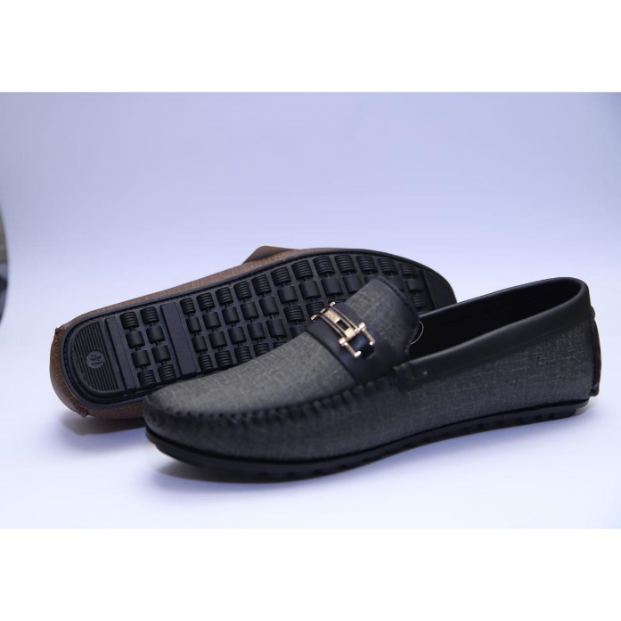

Stylish loafer men shoes multicolor for office/ college casual use latest design

Product details of [WB Fashion] Stylish loafer men shoes multicolor for office/ college casual use latest design

* Best for formal as wel casual wearMade of premium quality materialStuning gold and silver buckle designsKiller combo of beauty and durabilityFavourite choice of youth in summer 2022Best for walking, jogging, shopping or any outdoor activity.Never fail to impress

Welcome to WB fashion's summer collection 2022. A unique blend of beauty and elegance. Our Summer collection 2021 has been a hit among masses and this time even more beauty and charm has been added to it. Our brands have a unique ultra cut designs with easy to wear formal as well casual footwear.

Here officially launching our formal shoe collection exclusively on Daraz for our valuable online customers. Officially designated as Q series, these beautiful formal shoes are available in vast colors and stunning buckle designs to make your looks wow.